Phishing Email Detection & Awareness System
Analyst Name: Tanvi Sachin Itagikar
Date of Investigation: April 21, 2026
Project Goal: To detect if an email is real (Legitimate) or fake (Phishing) using technical header analysis.

1. Identification of Phishing Indicators
During my investigation, I found the following "Red Flags":
- Deceptive Subject Lines: Using emotional "Clickbait" (e.g., "We’re done after tonight...") to trick users into opening the email.
- Return-Path Mismatch: In the second sample, the "From" address showed trusted-bank.com, but the hidden "Return-Path" showed attacker@bad-domain.com.
- Authentication Failures: Technical checks for SPF, DKIM, and DMARC all returned a FAIL status. This means the sender is pretending to be someone else.
- Urgent & Scaring Language: Using words like "Urgent: Your account has been suspended" to create panic.
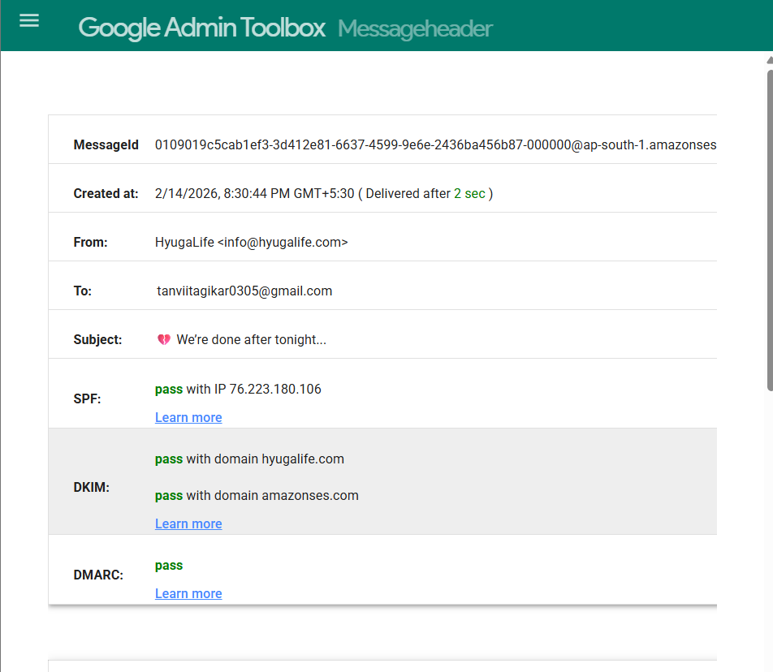

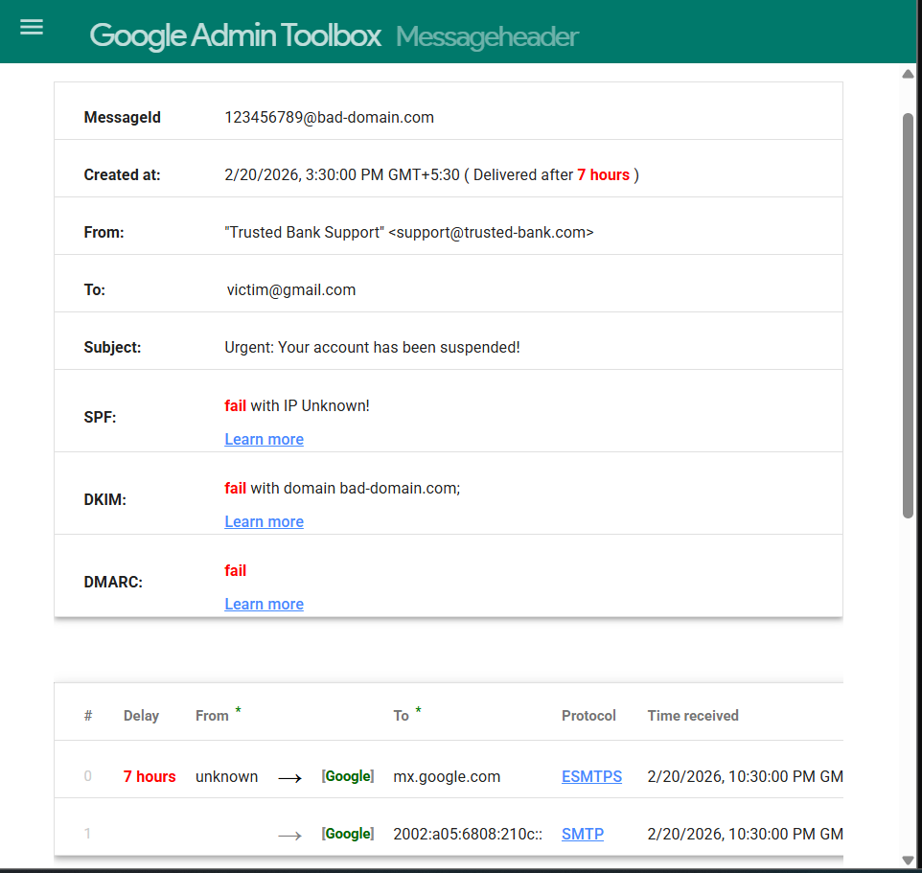

2. Email Risk Classification
Based on my technical analysis, I have classified the emails as follows:
Case Study | Sender Domain | Tech Result (SPF/DMARC) | Risk Level
Sample 1 | hyugalife.com | PASS ✅ | SUSPICIOUS (Clickbait) - Safe server but uses confusing marketing tactics.
Sample 2 | trusted-bank.com | FAIL ❌ | PHISHING (Critical) - This is a fake email designed to steal data.

3. How the Attack Works
This is a Credential Harvesting attack using Domain Spoofing:
- Impersonation: The attacker "spoofs" (fakes) the sender's name to look like a real bank.
- Failing the Test: Because the attacker does not own the bank's server, the digital signatures (SPF/DMARC) fail when the email is received.
- The Trap: The email contains a link to a "Verify Account" page.
- The Theft: If the user enters their password on that page, the attacker captures it instantly. This is called "harvesting" your credentials.

4. Clear Prevention Tips for Users
- Check the Sender: Do not just look at the name. Look at the actual email address.
- Hover Before You Click: Place your mouse over any button or link to see where it really takes you.
- Use Security Tools: Use tools like Google Messageheader to check if the SPF/DMARC passed or failed.
- Enable 2FA: Always use Two-Factor Authentication. Even if an attacker steals your password, they cannot login without the OTP.

5. Do’s and Don’ts for Employees
✅ DO's (Best Practices):
- Report any suspicious email to the IT or Security team immediately.
- Check for spelling and grammar mistakes which are common in phishing.
- Verify urgent requests by calling the person or company on their official phone number.
- Look for the "signed-by" and "mailed-by" sections in your email app.
❌ DON’Ts (Risky Actions):
- Don't click on links in emails that ask for personal information.
- Don't download attachments (like .zip or .pdf) from people you do not know.
- Don't share your OTP, Password, or PIN with anyone, even if they claim to be from "Support."
- Don't use public Wi-Fi to log into sensitive company or bank accounts.

Conclusion:
Header analysis is the best way to find the truth about an email. My project proves that even if an email looks professional, the technical signatures (SPF, DKIM, DMARC) reveal if it is a dangerous fake.

